CAPACITIVE TOUCH SENSOR

Printed Circuit Board

**SOLDERING/ASSEMBLY INSTRUCTIONS**

Center for Functional Fabrics

July 2019

PCB Soldering User Manual

**Tools:**

1. Digital Multimeter with resistance and diode settings
2. Temperature-controlled soldering iron
3. Solder (rosin-core)
4. Soldering flux
5. Soldering mat
6. De-soldering wick
7. CTS printed circuit board (CTS PCB)
8. Fume extractor
9. Wire clippers/cutters

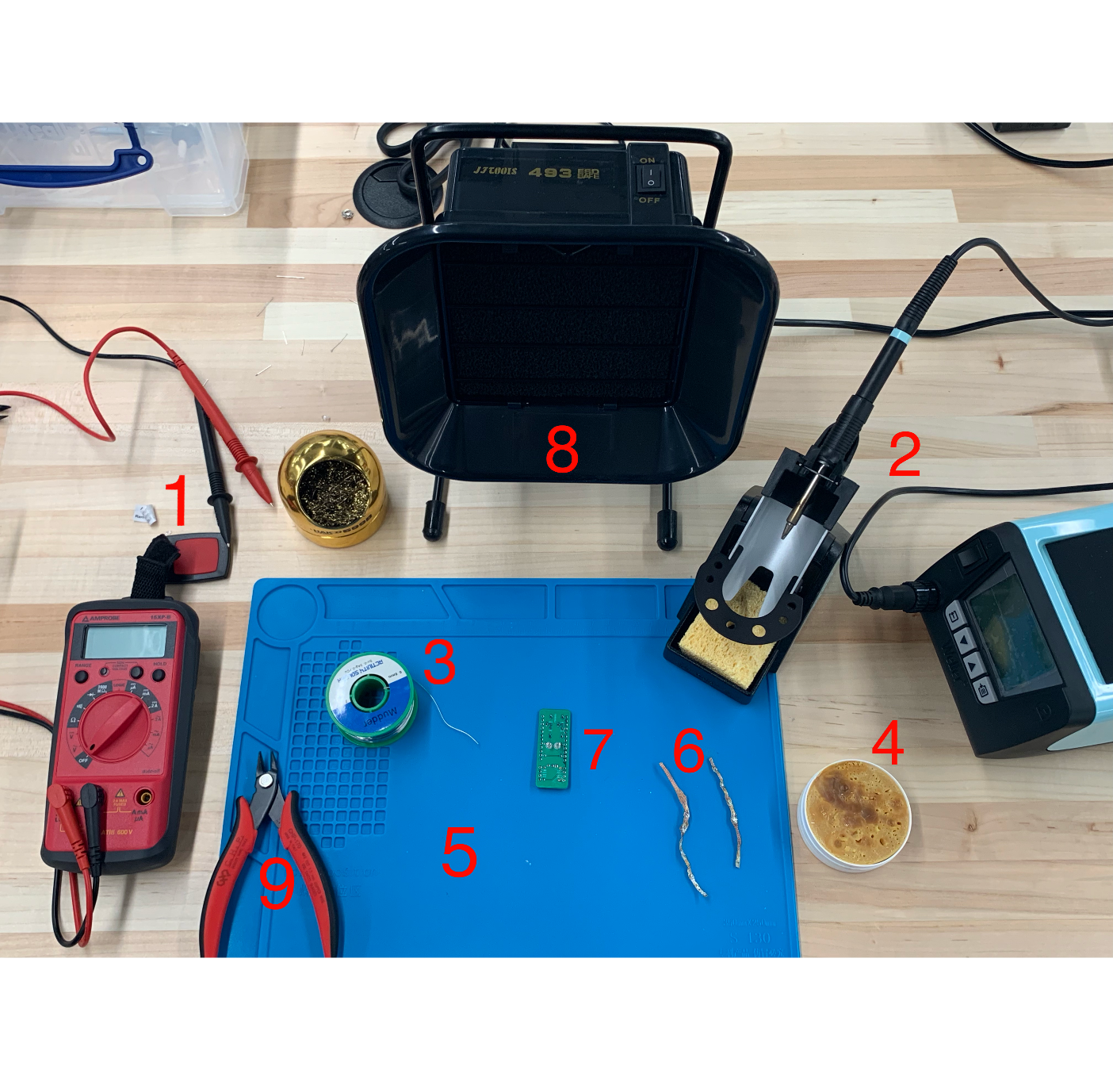

**Parts (quantity specified in parenthesis):**

1. **(4)** Through-hole mount 1% tolerance resistors
2. **(1)** 100 ohm
3. **(1)** 150 ohm
4. **(2)** 4.7kohm
5. **(2)** 3mm through-hole mount LEDs, red and blue
6. **(1)** 3-pin right-angle polarized Molex kk-156 connector
7. **(2)** 1MOhm trimming potentiometer
8. **(2)** 12x1 female sockets
9. **(2)** 4x1 right angle male pin headers
10. **(1)** CTS PCB
11. **(1)** PJRC Teensy 2.0 microcontroller

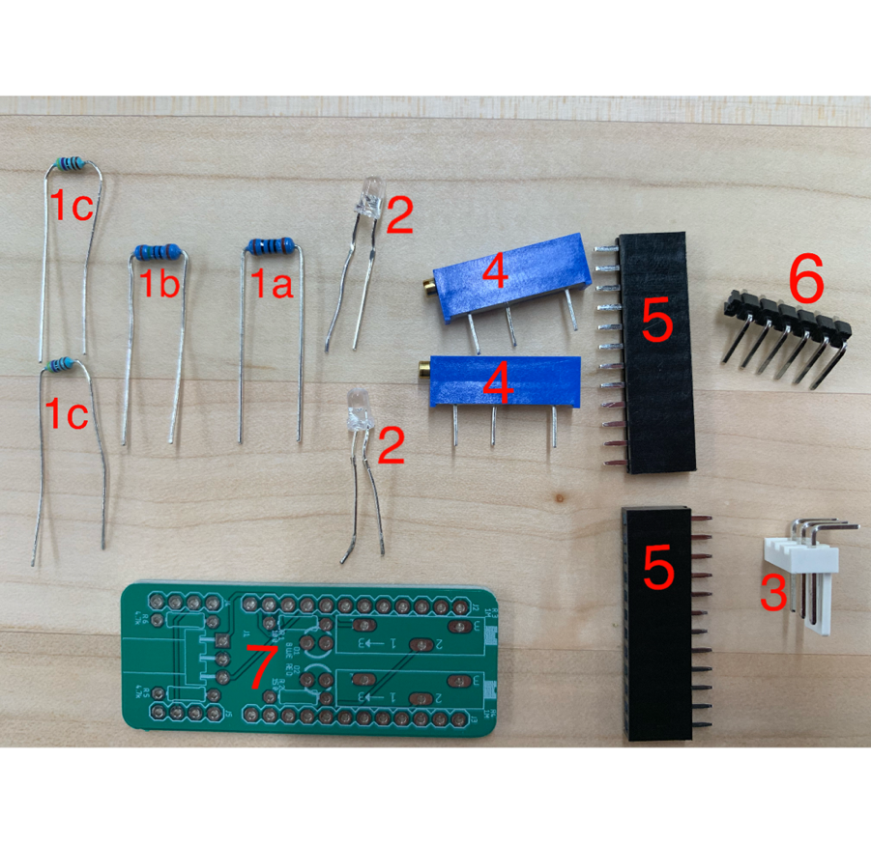

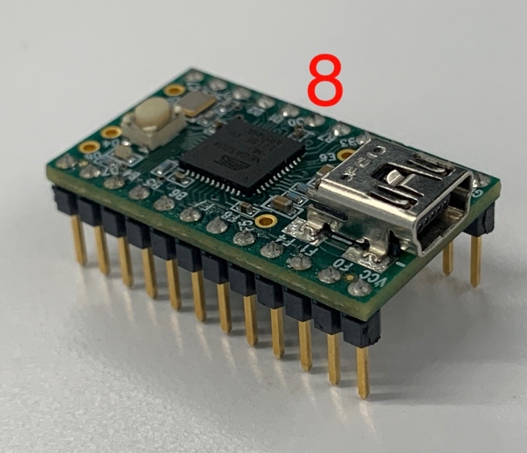

**Soldering:**

Heat up soldering iron to approximately 700 degrees Fahrenheit. Hold soldering iron with dominant hand and the end of the solder roll with other hand close to the base of the pin, near the desired pad. Once a drop of solder heats up onto soldering iron tip or the resistor pin, quickly but carefully press iron into base of pin and move iron up. Solder will cool quickly. If solder does not melt all the way around the pin, press iron back into solder clump, move iron up, and repeat until PCB base conducts solder around the pin in a cone shape. Add solder to iron pressing process as needed.

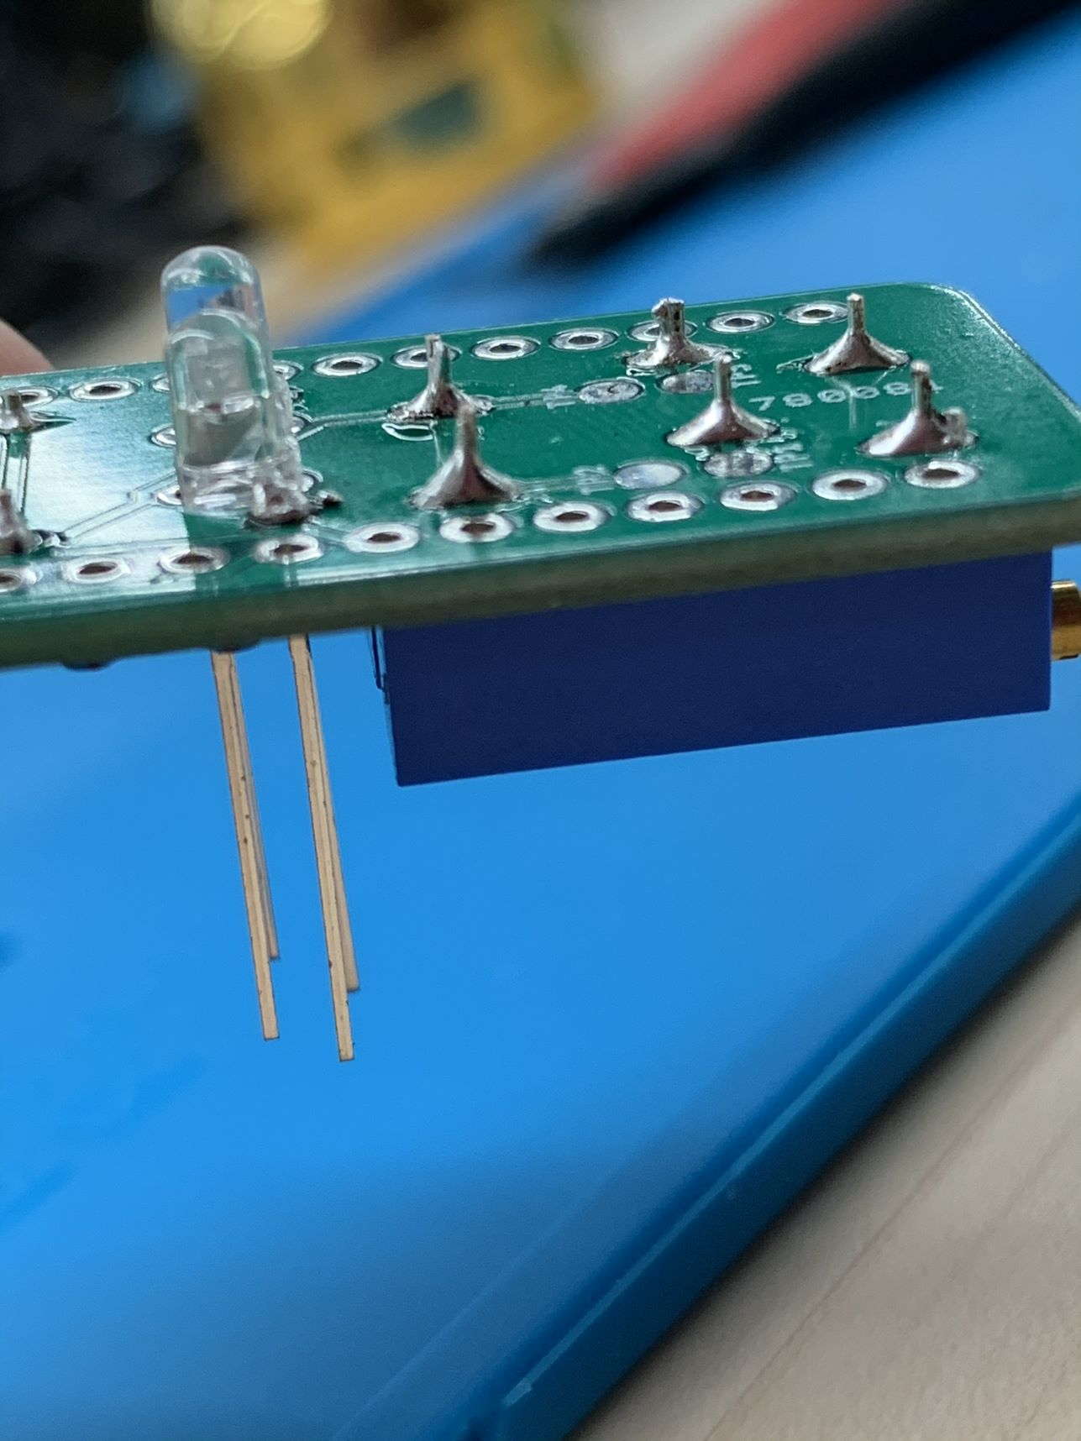

**Tip:** If solder accidentally covers a through-hole or bridges two contacts, remove the solder with the de-soldering wick. Apply flux to the wick and place it on the solder. Hold the iron on the solder and allow the wick to absorb the solder. If the wick becomes saturated, cut the wick and repeat the process with a new wick until solder is removed.

**Assembly process:**

RESISTORS

Step 1) Measure resistors with a digital multimeter (DMM) to verify the resistance. The resistors have no polarity and leads can be connected to the DMM in either direction.

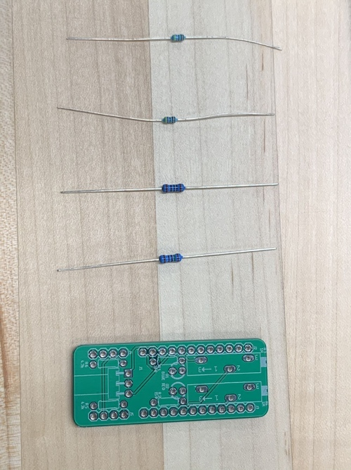

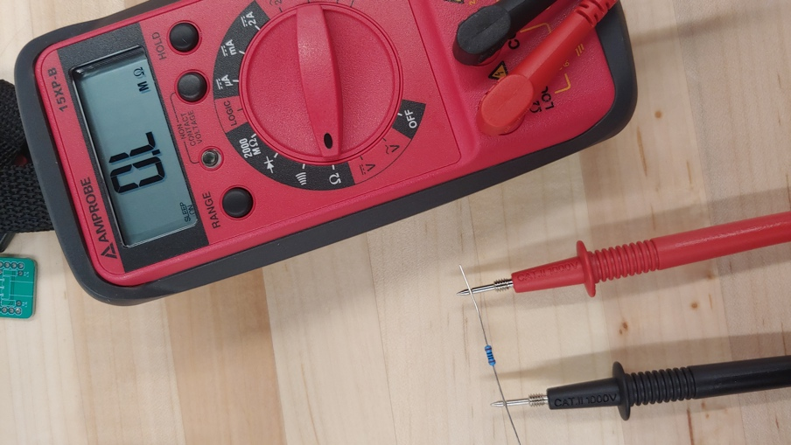

Step 2) Bend the resisters leads at right angles and insert them through their respective holes on the top of the CTS PCB, shown below. The white silkscreen marks the position of the resistor and its value.

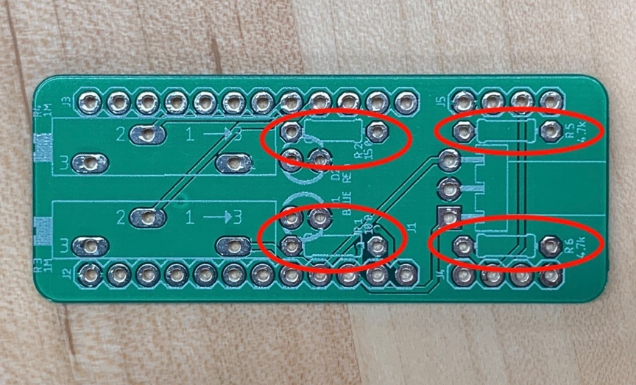

In R1 insert a 100k Ohm Resistor

In R2 insert a 150k Ohm Resistor

In R5 & R6 insert a 4.7k Ohm Resistor

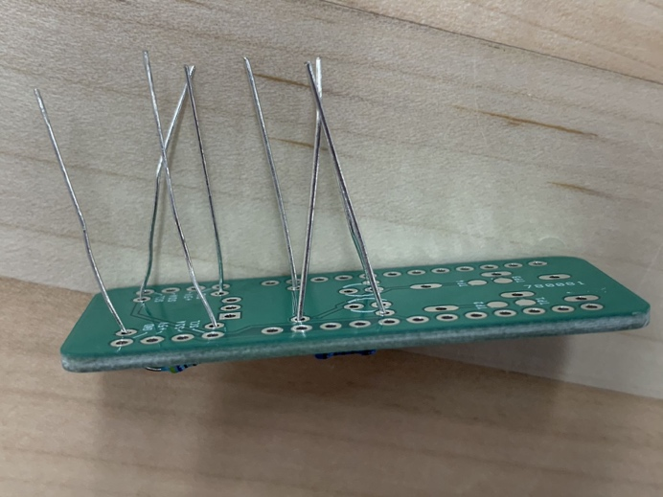

Step 3) **Solder** each pair of pins on the resistors. The resistor chassis should be flush with the top of the PCB when soldered. Clip excess leads about 1mm away from the bottom of the PCB.

LEDs

Step 4) Test the LEDs using the diode setting on the DMM. Connect the black (negative) probe to the shorter lead on the LED and connect the red (positive) probe to the longer lead. If the LED is in working order, it will illuminate.

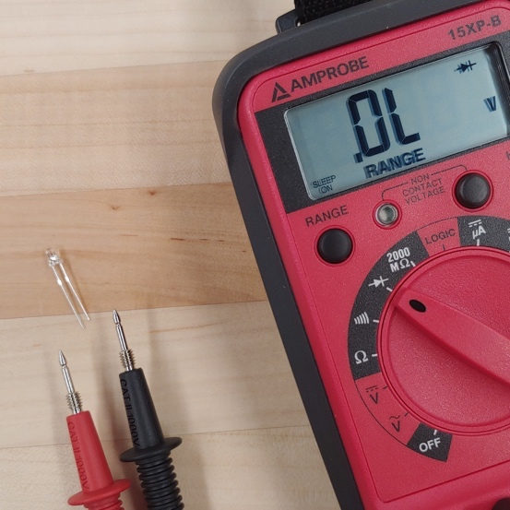

Step 5) Insert the LED leads into corresponding holes (RED LED, BLUE LED) through the back side of the PCB. The longer LED pin should be inserted into the positive hole facing the potentiometer silkscreen.

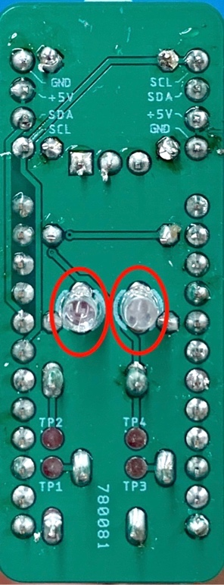

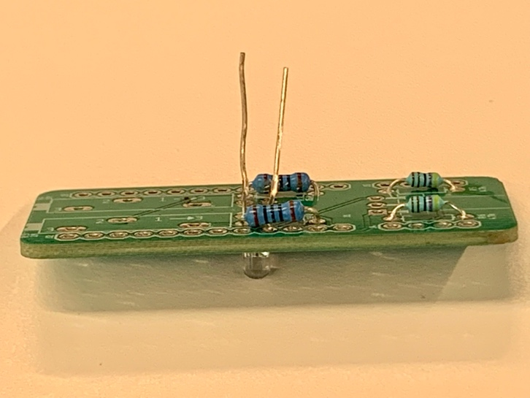

**Solder** and then clip the LED pins.

POTENTIOMETERS

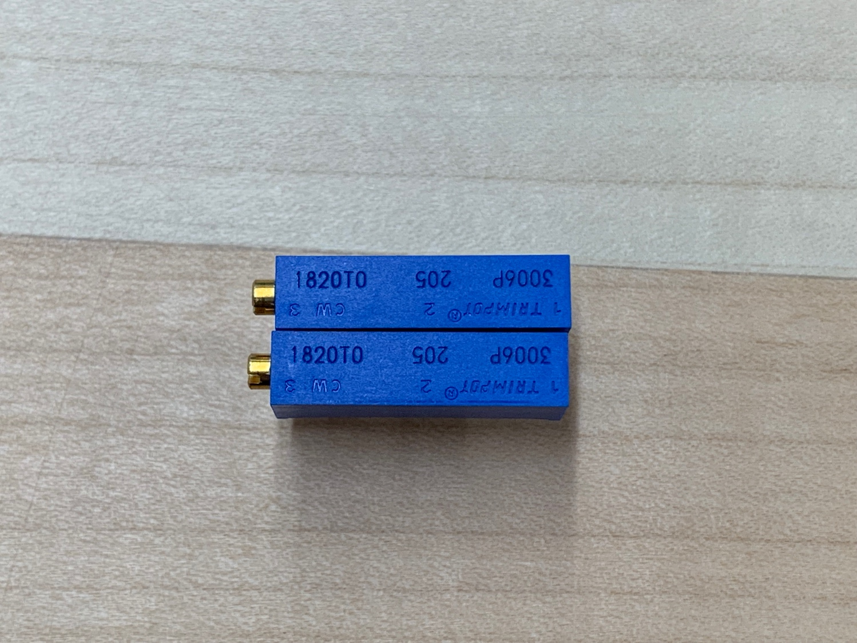

Step 6) Insert the potentiometers into the holes at R3 and R4.

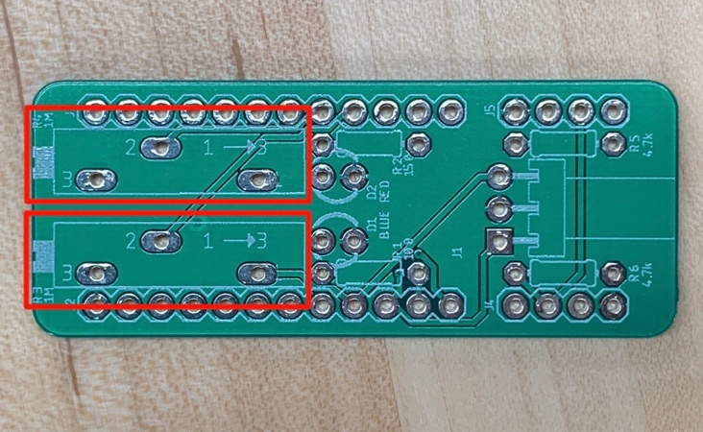

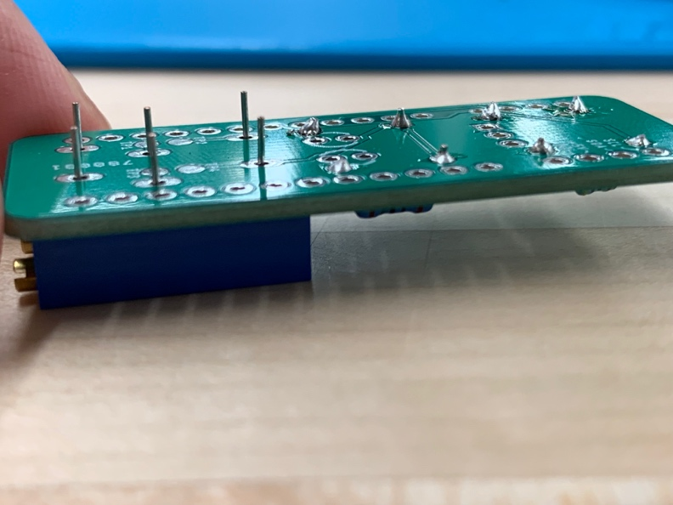

**Tip:** Lay the PCB on top of both potentiometers. Use the table to maintain the positioning of the potentiometers when soldering.

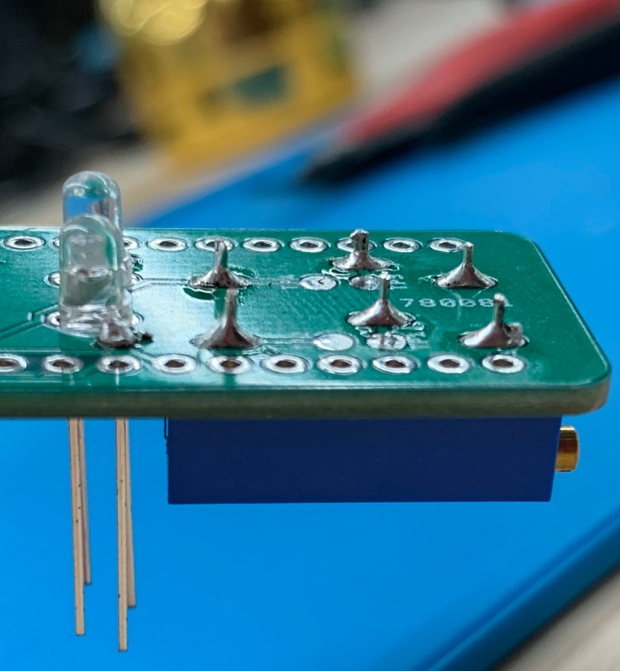

**Solder** and clip (6 pins total)

TEENSY 2.0

Microcontroller

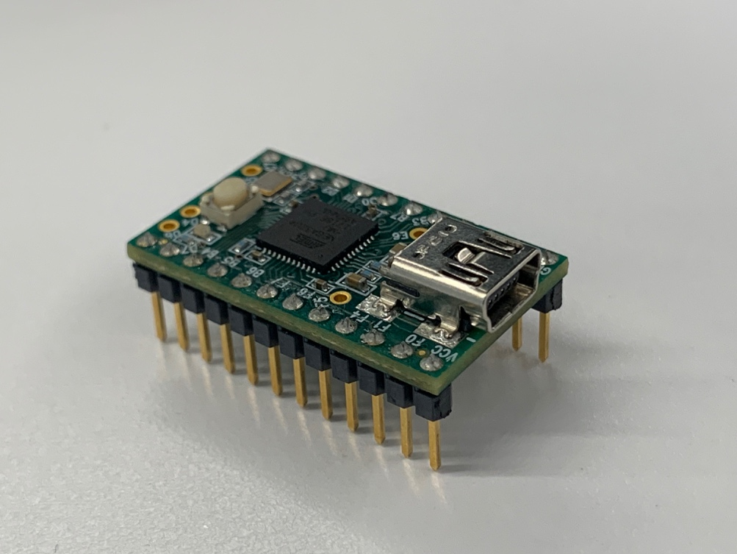

Step 7) Insert a set of 12 female headers into the J2 and J3 pins designated on the PCB.

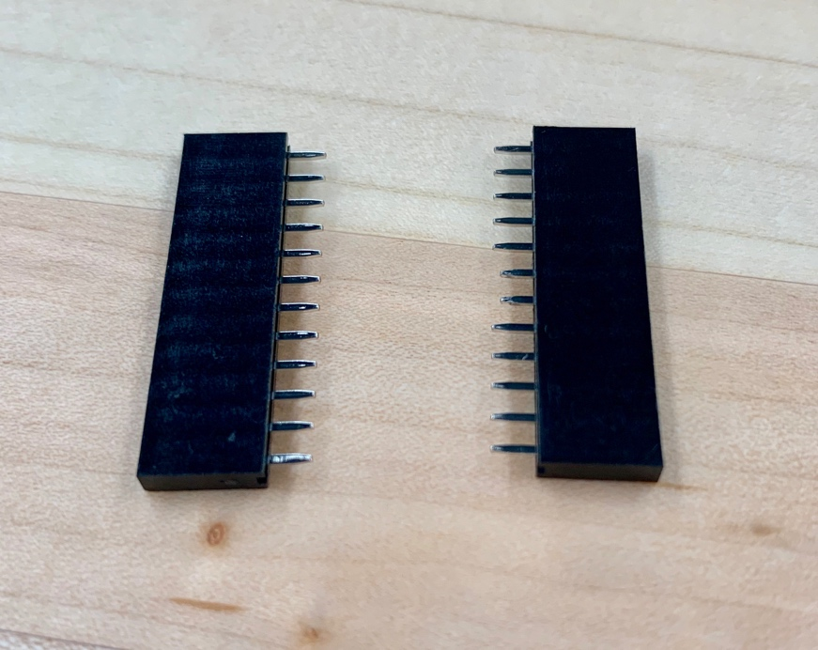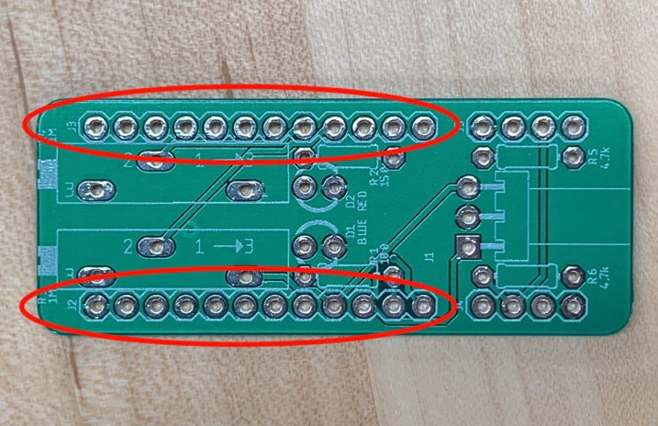

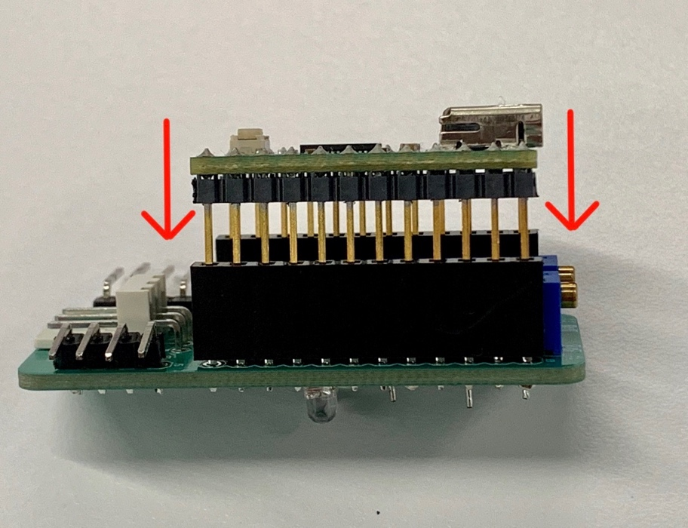

**Tip:** Before soldering all 24 pins, insert the Teensy 2.0 microcontroller into the female headers so that the pins are soldered in good alignment for insert.

Step 8) **Solder** header pins (24 total). Do not clip the excess pin length. You may remove the Teensy 2.0 device from the PCB or keep it now that it’s aligned to fit.

MALE HEADERS

Step 9) Take two right-angle male pin headers and insert them into the designated PCB holes so that the angled pins are facing out towards the edges of the board. **Solder** the four pins protruding from the back of the PCB but do not clip the pins.

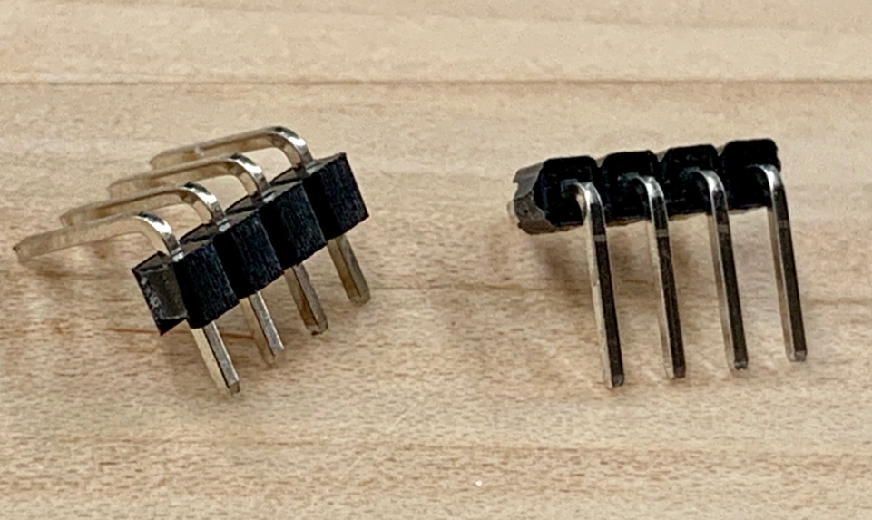

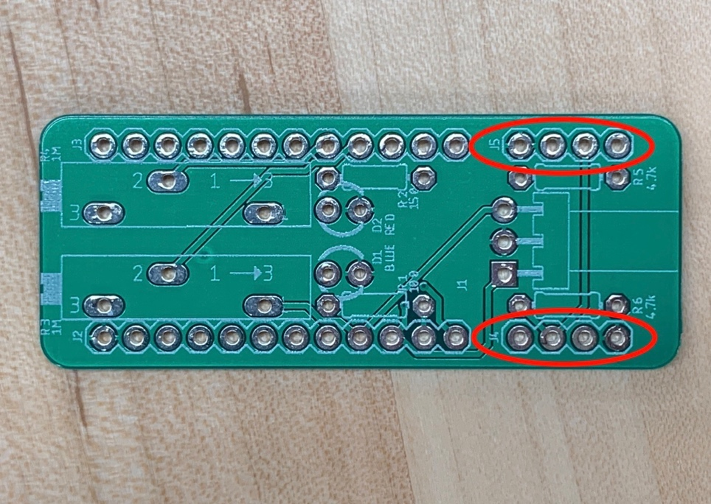

Molex kk-156

Step 10) Lastly, insert one 3-pin right-angle Molex kk-156 connector pin into the PCB at J1. **Solder** the leads at the bottom of the board butdo not clip the pins.

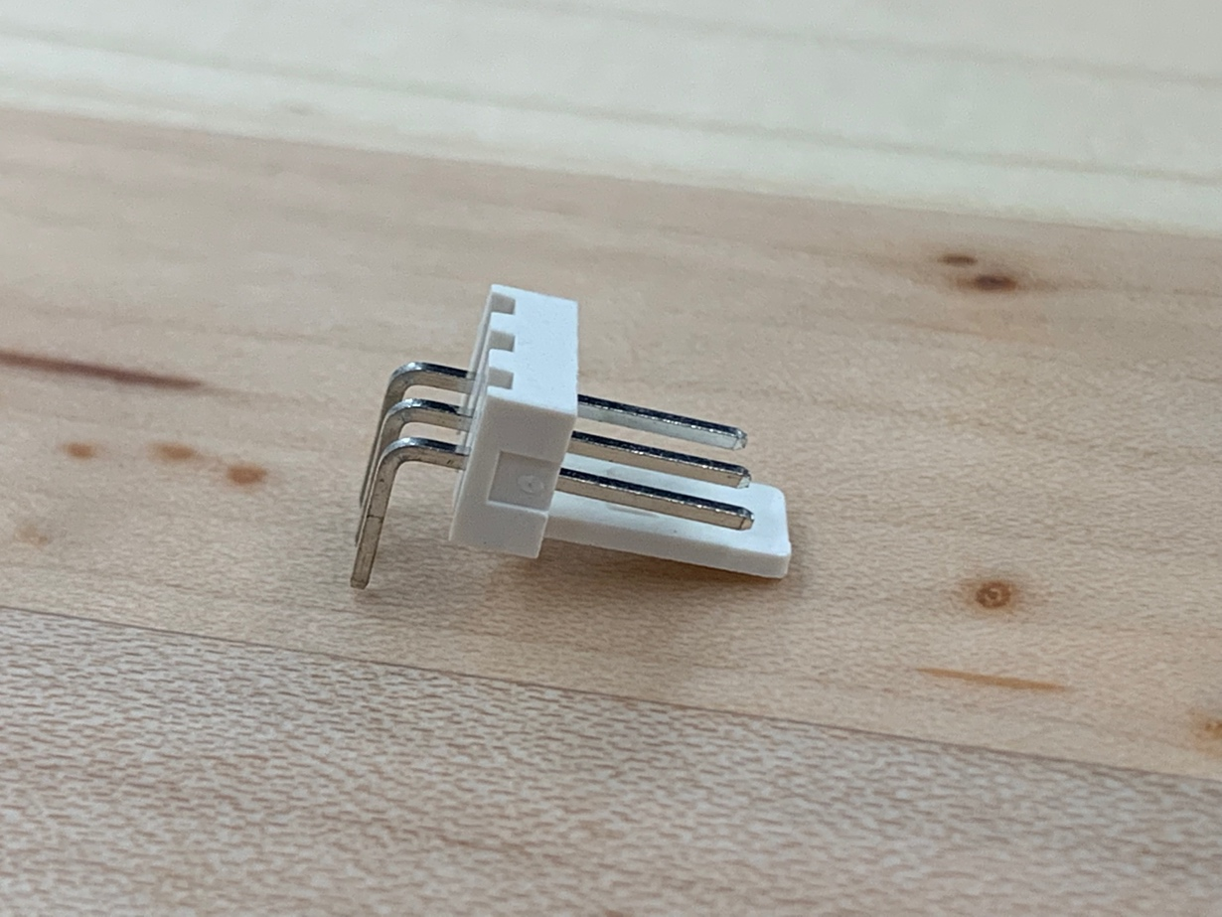

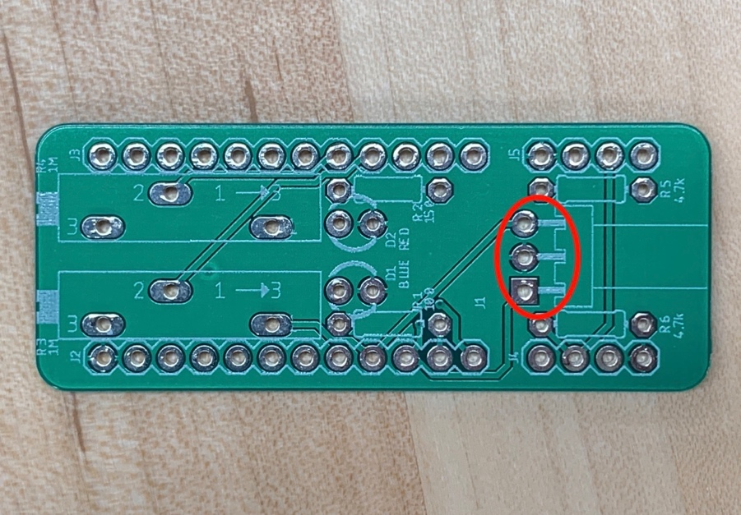

FINAL ASSEMBLY

